Project Development Phase II

Responsive and Design of Dashboard
The responsiveness and design of a dashboard for analyzing the performance ToyCraft Tales: Tableau's Vision into Toy Manufacturer Data is crucial to ensure that the information is easily understandable and actionable. Key considerations for designing a responsive and effective dashboard include user-centered design, clear and concise information, interactivity, data-driven approach, accessibility, customization, and security. The goal is to create a dashboard that is user-friendly, interactive, and data-driven, providing actionable insights to improve the performance ToyCraft Tales: Tableau's Vision into Toy Manufacturer Data. Once you have created views on different sheets in Tableau, you can pull them into a dashboard.
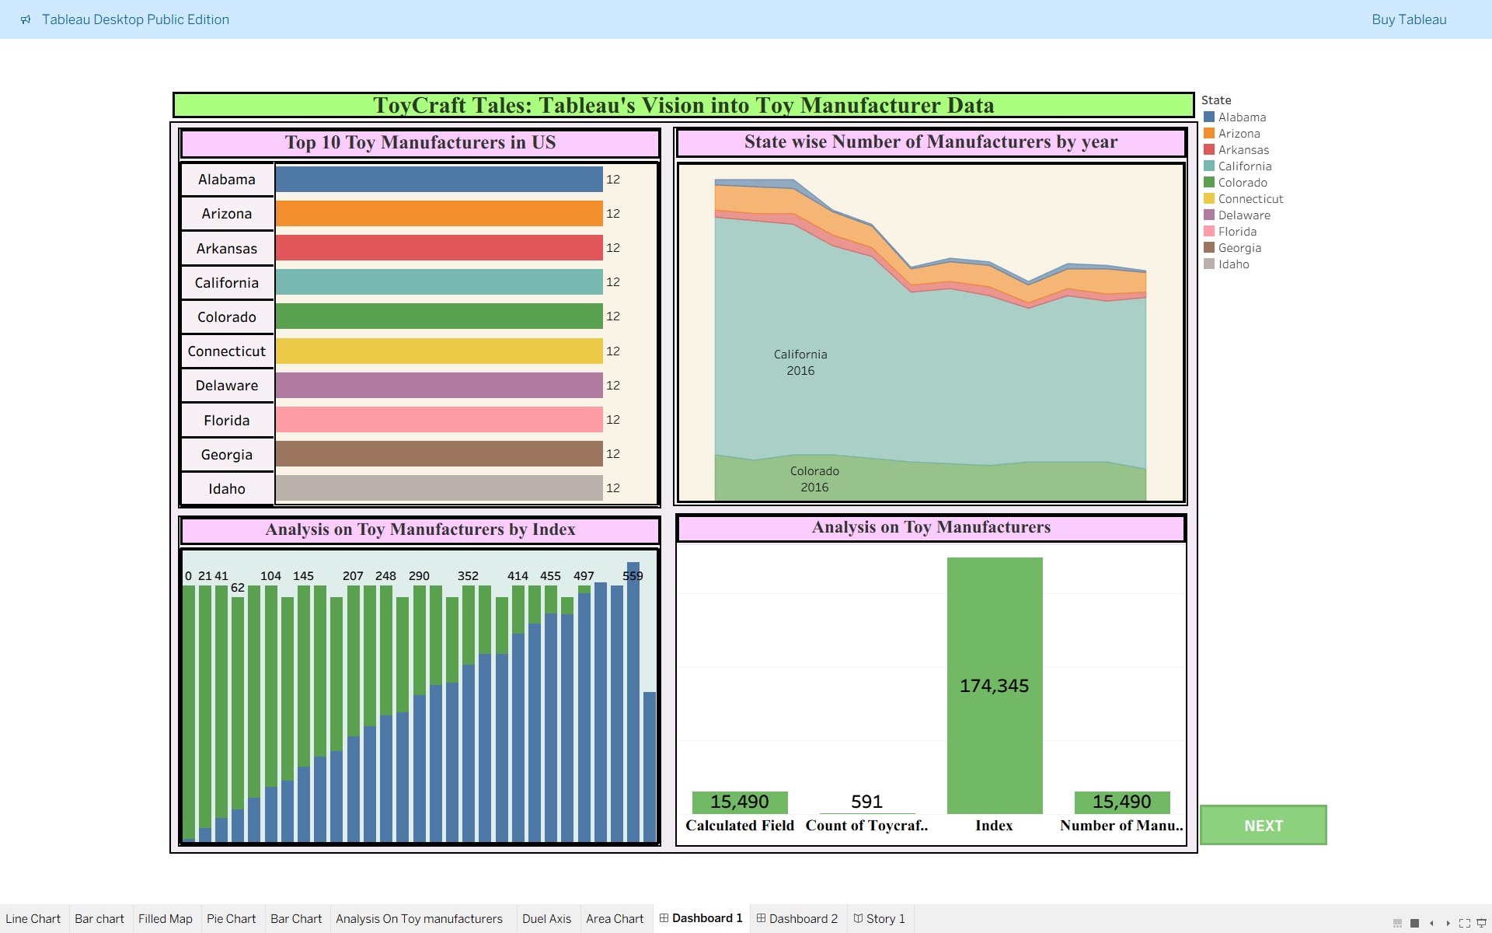
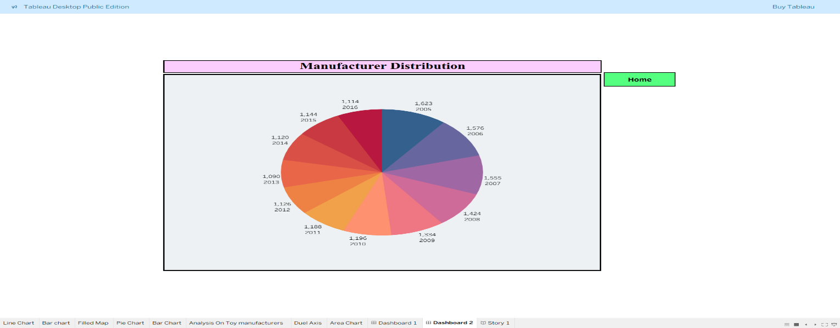

No of Scenes of Story ( 5 Scenes)
The number of scenes in a storyboard for a data visualization analysis of ToyCraft Tales: Tableau's Vision into Toy Manufacturer Data will depend on the complexity of the analysis and the specific insights that are trying to be conveyed. A storyboard is a visual representation of the data analysis process and it breaks down the analysis into a series of steps or scenes.
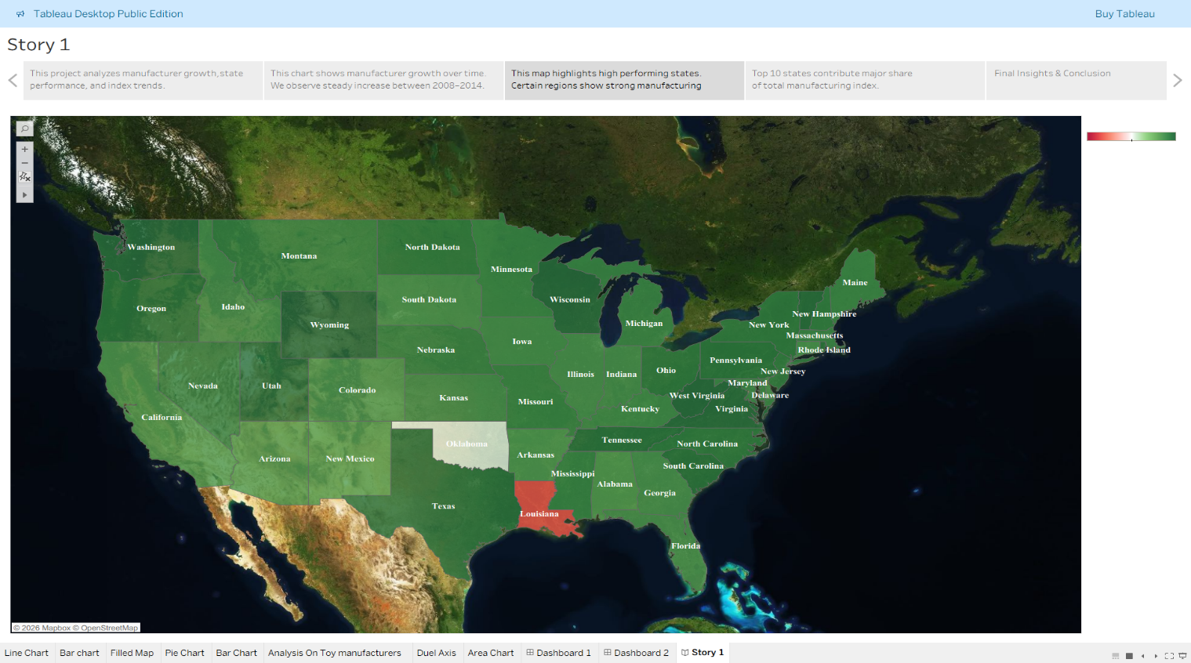
Flask Folder link:
https://drive.google.com/drive/folders/1oB7Rn3p4o0BpQuw1YMsuo_RutFz8hjcs
Dataset Link:
Toycraft_Tals.csv.xlsx
Dashboard Public Link:
https://public.tableau.com/shared/4FSC8M87J?:display_count=n&:origin=viz_share_link
Story Public Link:
https://public.tableau.com/shared/C74TNZTNY?:display_count=n&:origin=viz_share_link

